August, 2011

Post Office Box 1411, LaPlace, LA 70069-1411



From the President’s Pen

I would like to thank the board for all of its hard work and support of our fundraising efforts. In May, we presented the encore performance by Leslie Castay. I cannot thank Leslie enough for volunteering her time and talents in support of RRAHC. I also must recognize and express gratitude for the untiring efforts of Jane DesRoches. Not only did she use her enormous clout to get Leslie for us; but without her tenacious and unwavering promotion of the event, I don't think we could have filled the St. John Theater to such extent. I must also thank the entire staff of the St. John Theater for providing the perfect venue, and particularly Denise Borell, for helping us with the staging and set-up. This event was surely well received and a great success!

We are now accepting grant applications for 2012. If you are interested or know anyone who should apply, please visit our website www.RRAHC.org to obtain the 2012 Grant Application Form. The cut-off date is October 8, 2011, for all applications. Our grant committee will make recommendations which will be voted on in November and the grants will be funded at our General Membership meeting in January, 2012. Please look at our calendar on the website for dates and times.

As always, thanks to all of our patrons, members, and guests, who year after year continue to support RRAHC. Without them, we would be unable to provide the grants that are so desperately needed by the organizations that benefit from them.

Judy L. Mackles, President 2011

Judy L. Mackles, President

2011 Officers &
Board of Directors

President
Judy Mackles

Vice President
Harold Flynn, Jr.

Secretary
Brenda Birner

Treasurer
Sharon Kell

United Way Liaison
Suzanne Friloux

Partnership for the Arts
Marilyn Vicknair

Newsletter
Robert Fisher

Board Members
Paula Adams Ates
Paul Aucoin
Mary Hotard Becnel
Sandra Chaisson
Angelique Daigle
Randy Desoto
Jane Des Roches
Audrey Giardina
Betty Haydel
Trish Salbador
Marilyn Smith
Judy Songy
Vicky Tamplain
Rick Treuting

***************************
501C3 Not-for-Profit Corporation,
Federal Tax Identification

2010 Angelus Award Recipient:
Louisiana Artist Association

RRAHC presented its 13th annual Angelus Award to the Louisiana Artist Association (L.A.A.) on Wednesday, January 12, 2011. This prestigious award is presented
yearly to honor a person or organization in the River Region that shares the same goals as RRAHC: to
support and champion the preservation of local arts, humanities, or culture. The Louisiana Art Association specifically states that it was founded on the premise that arts and humanities of every kind are integral parts of everyday life. L.A.A. serves as an umbrella organization to enrich the quality of life in Louisiana through the promotion of the works of Louisiana artists and through the preservation and enhancement of state culture. It also assists its members by exhibiting and publicizing their works in a dignified manner and by sponsoring lectures, demonstrations, and product tours.

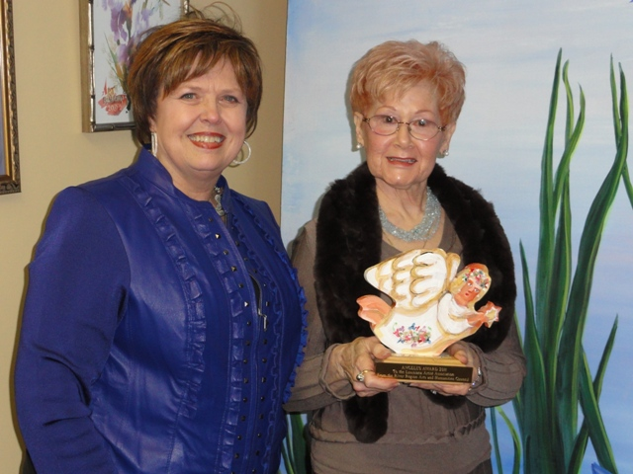

Audrey Giardina, Vice-President of LAA poses with Judy Mackles, President of RRAHC

2011 Grant Recipients

RRAHC presented $30,000 to organizations in tri parishes
(St. Charles, St. John, and St. James) to host educational and cultural events in 2011. Grant recipients received their awards during a reception on Wednesday, January 12, 2011, at
6:00 p.m., located at 301 W. Airline Hwy.,
Suite 201, La Place, LA.

RECIPIENTS:

St. Charles Parish
Destrehan High School
River Region Ballet, Inc.
River Region Drama Guild, Inc.
St. Charles Borromeo School
Sacred Heart of Jesus Elementary School Drama Club
River Road Historical Society
Hahnville High School
Louisiana Artist Association
St. Charles Art Guild
Harry Hurst Middle School
St. Charles Parish Public Schools
St. Charles Parish 4-H Performing Arts Club
Community Chorus of River Parishes, LLC

St. James Parish
Crazy ‘Bout History, Inc.
Oak Alley Foundation
St. James Gifted Center
St. James Career & Technology Center
Sixth Ward Elementary
St. James Library
St. James High School
St. James Parish School Board Talented-In-Music
Paulina Elementary School
Gramercy Elementary

St. John Parish
Riverside Academy
West St. John Elementary
St. John Theatre
Ascension of Our Lord School
Emily C. Watkins Elementary School
St. John Parish Schools – Gifted Teacher-Margaret Meynard
St. John Library

"Leslie Castay...unscripted' at
St. John Theatre

RRAHC presented local artist and
native Leslie Castay in an evening of
songs, traveling the winding road to
Broadway and back again. Selections
ranged from standards to classic
Broadway (Berlin and Arlen to Loesser, Rodgers, and Sondheim) and from Jazz and Pop (Sting and Carly Simon).
Castay, a Broadway actress and star of the NOLA premiere of Grey Gardens, repeated her critically acclaimed performance at the St. John Theatre in Reserve on Friday, May 20, 2011.
One attendee, Roberta August stated, "Leslie was professional; she knew her craft, and she was a delight to the crowd. The event was wonderful!" Many thanks to everyone who helped to make this fundraiser a success, and special thanks to Leslie for sharing her extraordinary talent here in the River Parishes.

“Alice and the Rabbit”


RRAHC 2012 Grants

RRAHC has grants available for qualified individuals or groups in St. Charles, St. James, and St. John Parishes to promote the development of arts and humanities. Grants will not exceed $1,000 per application. Applications must be postmarked by Saturday, Oct. 8, 2011, and must be typed or printed on the official form. Recipients will be notified via mail or email. Grants will be announced in November and will be awarded during the General Membership Meeting January, 2012.

About River Region Arts & Humanities Council (RRAHC)

The River Region Arts & Humanities Council is a grant organization designed to promote the arts and humanities, preserve and enhance local culture, and support art education in the River Region. RRAHC receives support from the United Way of St. Charles. The River Region Arts and Humanities Council was founded on the premise that the arts and humanities are an integral part of everyday life. The purpose of the council is to serve as an umbrella organization to enrich the quality of life within the region through the promotion of the arts and humanities, the preservation and enhancement of local culture, and the support of art education through fund-raising and program development. Since 2000, RRAHC has awarded over $325,000 in grants.
Please cut and return this application with your check made payable to RRAHC and send to: Judy Mackles, 17 Country Club Dr., La Place, LA 70068

Name _________________________________________________________________
Membership level _______________________________________________________
Address _______________________________________________________________
Phone: Day __________________________ Evening _________________________
E-mail __________________________________ Fax __________________________
Membership Levels

Student $5
Senior Citizen (60+) $10
Individual $20
Family, Club, or Organization $35
Small Business $100
Saint $200
Corporate $350
Patron $500
Angel $1000


With the support of the United Way of St. Charles, RRAHC has awarded over $300,000
to organizations in St. Charles, St. John, and St. James Parishes to host educational and
cultural events in the River Region since 1998.
Please cut and return this application with your check made payable to RRAHC and send to: Sandra Chaisson, One Ormond Trace, Destrehan, LA 70047

Name _________________________________________________________________
Membership level _______________________________________________________
Address _______________________________________________________________
Phone: Day __________________________ Evening _________________________
e-mail __________________________________ Fax __________________________
Membership Levels

Student $5
Senior Citizen (60+) $10
Individual $20
Family, Club, or Organization $35
Small Business $100
Saint $200
Corporate $350
Patron $500
Angel $1000

